https://github.com/kishoreanandd/GEN-AI-WEEK2.git
No Question:
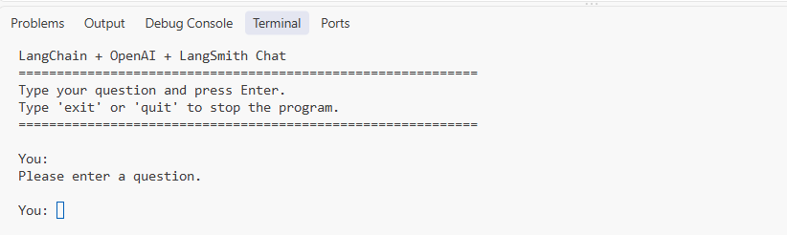
With Question: types of retriever
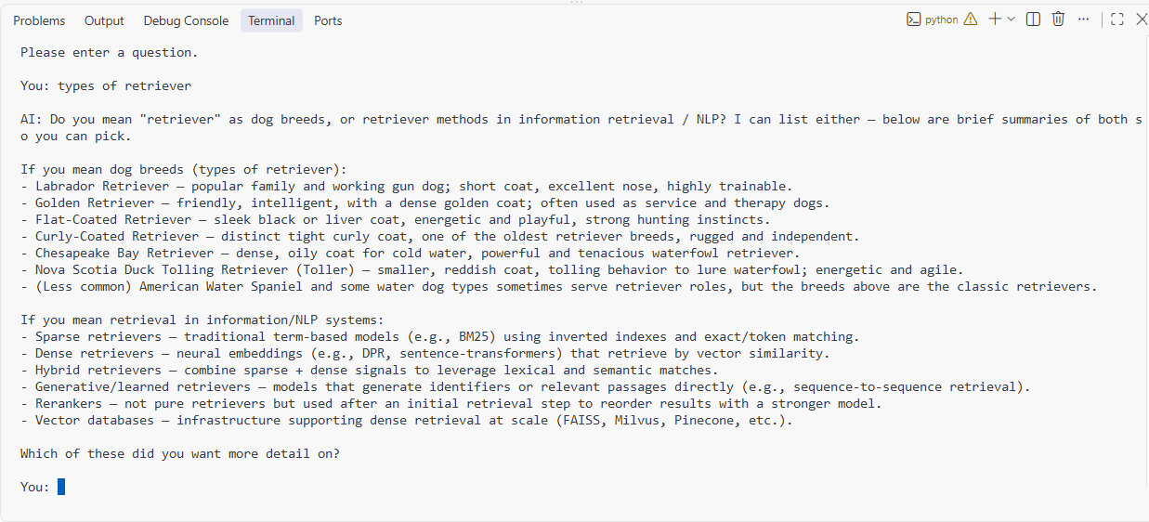
Exit Condition:
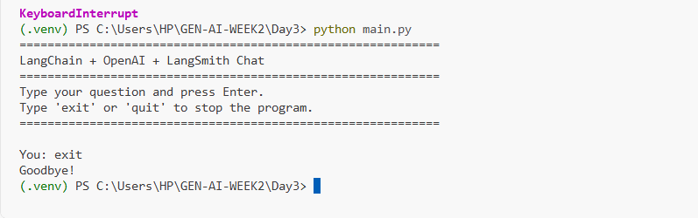

Langsmith Tracing:
